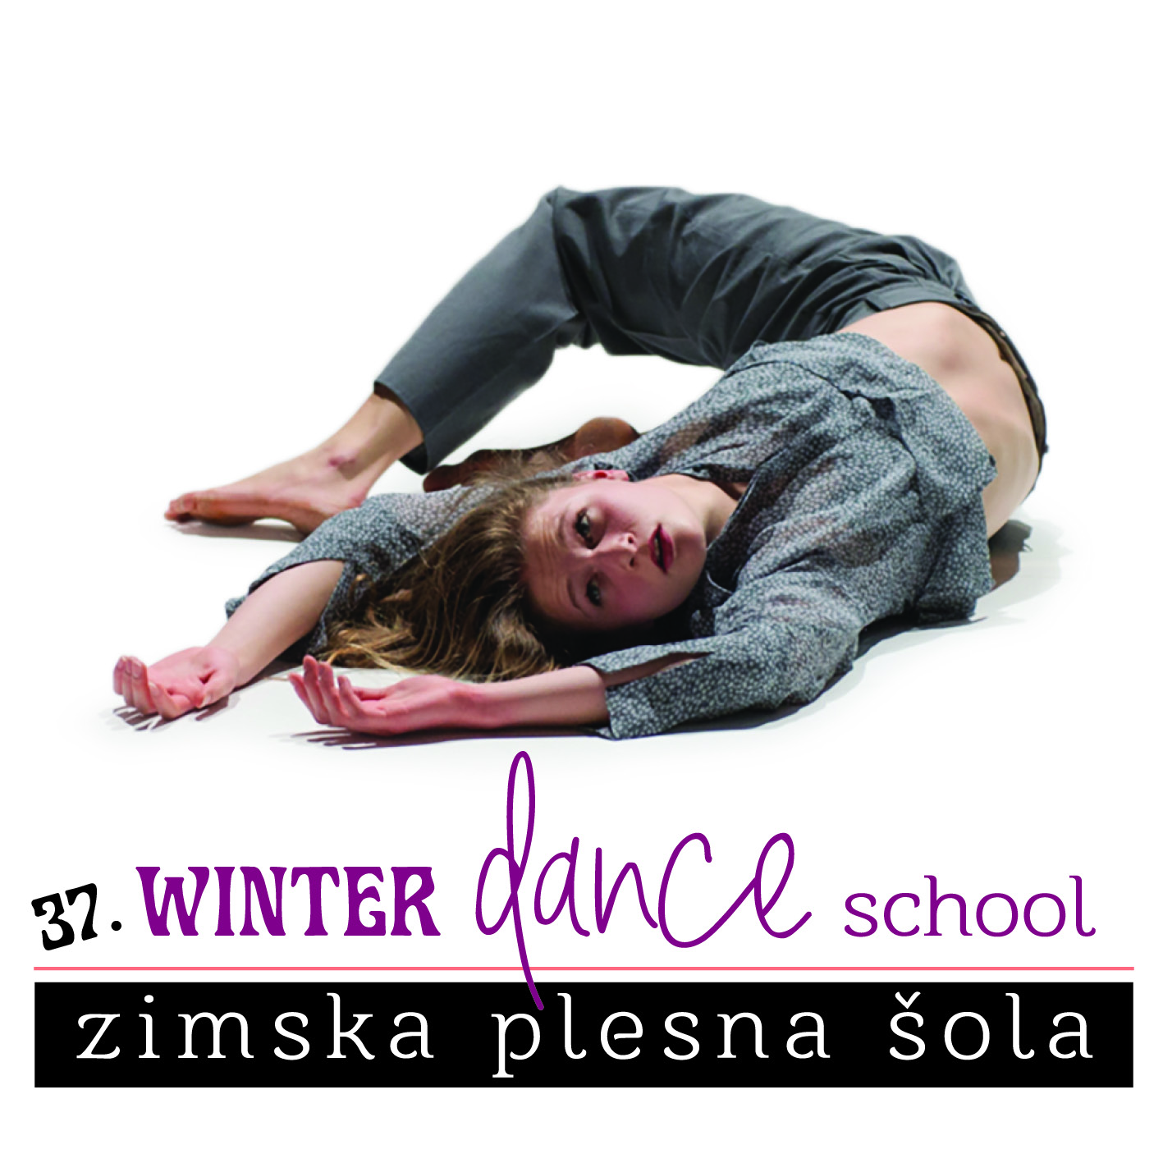

APPLICATION FORM
37th WINTER DANCE SCHOOL from February 25 to 28, 2022
(Apply soon. Cheaper workshops for payments received by 7th February.)

Name and Surname |  |  |  |  |  |  |  |  |  |  |  |  |  |  |  |  |  |  |  |  | Year of Birth
Address (street, post code, city)
Phone (mobile) |  |  |  |  |  |  |  |  |  |  |  |  | E-mail:
Dance activity (group, school, company)
PROGRAMME (highlight the chosen classes)
Contemporary ballet – Tina Dobaj | I | II
Iyengar yoga – Neža Polh | I
Zero space – Beno Novak | I | II
Follow the flow – Urša Rupnik | I | II
Contemporary dance 2 – Anamaria Klajnšček |  | II
Workshop Contact and partnering – Anamaria Klajnšček |  | II
Bailemos! Fusion solo salsa – Katja Čuk | I
Mentors workshop Children's dance creativity – Saša Lončar | I

City: |  |  |  |  |  |  |  | Date: |  |  |  |  |  |  |  |  |  |  |  | Signature:
I – BASIC: open for all levels
II – INTERMEDIATE / ADVANCED: more experienced
FULL TITLE OF THE PAYER
(highlight!) |  |  |  |  |  |  | alone |  |  |  |  | Institution / school/ other
Institution/school/other
Address /street, city
Poste code |  |  |  |  |  |  |  |  |  |  |  |  |  |  |  |  |  |  | City
Phone (mobile) |  |  |  |  |  |  |  |  |  |  |  |  |  |  |  |  |  |  | Fax
Tax number/VAT: |  |  |  |  |  |  |  |  |  |  |  |  |  | Amount: |  |  |  | €
City and date: |  |  |  |  |  |  |  |  |  |  |  |  |  |  |  | Signature of a responsible person for payment:
 |  |  |  |  |  |  |  |  |  | Rubber stamp:
Lower prices are valid if applications and payments are received until 7th February 2022!
(JSKD OI Maribor, Pobreška 20, Karantena, 2000 Maribor, Slovenia)
E-mail: minka.veselic@jskd.si,fax: + 386 2 23 42 112
Warranty: We take no responsibility for injuries and thefts. Regulate your own personal insurance and take care of your belongings.

