 |  |  | 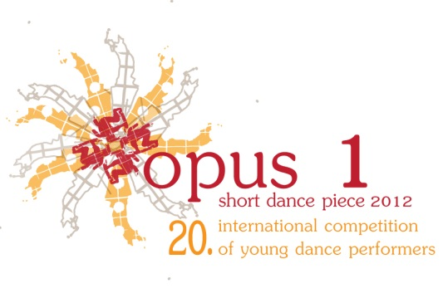
  Republic of Slovenia Public Fund  for Cultural Activities   | 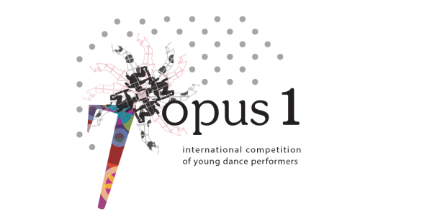
APPLICATION FORM

The correctly filled out application form with the required attachment must be sent by 18 April 2015, to:

nina.mesko@jskd.si (Nina Meško), for “OPUS 2015”

Age group (circle): B C

Type of dance piece: (circle, fill out)

a) Original solo dance piece (conceived and performed by the same person)

Title of the short dance piece:

__________________________________________________________________________________________
Name, surname and date of birth of the performer:

__________________________________________________________________________________________

b) Concept and performance (team – duet)

Title of the short dance piece:

__________________________________________________________________________________________
Names, surnames and dates of birth of the two dancers/co-authors:

__________________________________________________________________________________________

__________________________________________________________________________________________

Music (circle, fill out):

a) Recorded music (genre, author, title, band…)

__________________________________________________________________________________________
b) Live music (voice/sound emitters/instruments, names of the author and/or performers if they are not the dancers)

__________________________________________________________________________________________

Other information (e.g. designer of outfits, masks etc, if used):

__________________________________________________________________________________________

Team (school, centre, studio …):

__________________________________________________________________________________________

Address, e-mail, telephone number of the performer of the original piece, choreographer or representative in case of a team effort:

__________________________________________________________________________________________

Address, e-mail address and telephone number of the mentor:

__________________________________________________________________________________________

__________________________________________________________________________________________

REQUIRED ATTACHMENT: A self-authored written description of the piece’s concept including sources, starting positions and the creation process (maximum one A4 page). You are also obliged to provide a description of your dance piece in one to five sentences. The text shall be included in the theatre’s brochure in order to allow the audience to learn more about your piece.
You can send the video on a DVD or upload it in HD quality on YouTube and share the link.

Date: ______________ 2015

Signature:

The signature grants the competition organiser the right to record and/or broadcast/stream the performance in either audio or video as well as freely use such recordings for informative purposes without any liabilities or restraints.

